Bird Impact Assessment Study

132kV Distribution line
Soekmekaar – Singo - Mashau
Eskom Distribution – Northern Region
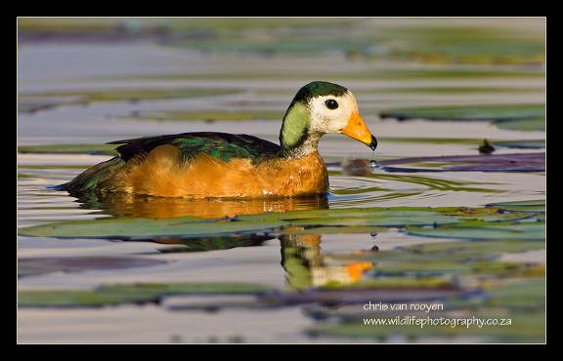
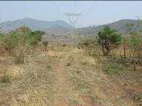

November 2008
Chris van Rooyen Consulting
30 Roosevelt Street
Robindale
Randburg
2194
South Africa
Tel. International: +27824549570
Tel. Local: 0824549570
Fax: 0866405205
Email: vanrooyen.chris@gmail.com

EXECUTIVE SUMMARY

Generally speaking, it is unavoidable that birds get killed through interaction with infrastructure, including power lines, despite the best possible mitigation measures. It is therefore important to direct risk or impact assessments and mitigation efforts towards species that have a high biological significance, in order to achieve maximum results with the available resources at hand. A pure scientific approach would only consider the effects of deaths on the sustainability of the population, but society places other values on certain species, e.g. aesthetic or commercial, which cannot be accounted for in a pure scientific approach.

In accordance with this principle, this impact assessment is primarily aimed at assessing the potential threat to threatened or Red Data species (biological significance) that occur or potentially along the proposed power line routes. However the proposed mitigation measures will benefit all the birds occurring in the study area, not just the Red Data species.

Collision with earth wire
Species most likely to be impacted on through collision with the earth wire and the likely locality of this impact are as follows:
- Black Stork, African Openbill, Yellow-billed Stork, African Pygmy-Goose, Pink-backed Pelican and Lesser Flamingo at dams.
- Cape Vulture and White-backed Vulture mostly at dams when visiting to drink or bath.
- Black Stork, African Openbill and Yellow-billed Stork in rivers, particularly the Klein Letaba River.
- White Stork and Secretarybird at arable lands.
- Various non Red Data species of waterbirds close to water sources such as rivers and dams.

Electrocution on pylons
The single steel pole design is generally a safe design from an electrocution perspective. The only recorded species that have been electrocuted on these designs are Cape Vultures. The insulator length of 1.5 metres is smaller than the wingspan of a vulture, which means that if a vulture decides to attempt to land on an insulator, there is a real risk of a phase-earth electrocution as it can conceivably bridge the gap between the phase conductor and the steel, earthed pole. Species most likely to be potentially impacted are Cape Vultures and White-backed Vultures, if they are congregating at water or at a carcass.

Habitat destruction
The species considered potentially impacted on by this line is the Half-collared Kingfisher and African Finfoot. This impact could occur in riverine vegetation if it needs to be cleared to make way for the line. The general lack of significant impacts by habitat destruction is largely due to the already relatively highly degraded nature of most of the study area. However, the further removal of any of the remaining large trees could impact on raptors in general, as it deprives them of roosting and nesting substrate.

Both the proposed alternative sites for the Singo substation can be described as degraded woodland with no large trees. It is unlikely that the larger Red Data species mentioned in this report will be significantly adversely affected by the construction of the substation and the resultant loss of 1 hectare of degraded woodland. This type of habitat is fairly well represented in the area and due to the mobility of the larger species, they could conceivably move out of the immediate area and forage elsewhere in similar habitat. The species that are most likely to be affected by the loss of habitat are the smaller species that are currently resident in that hectare of vegetation. It is not envisaged that any Red Data species will be permanently displaced by the habitat transformation that will take place as a result of the construction of the Singo substation.

The proposed alternative site 1 for the Mashau substation can be described as degraded woodland, while alternative site 2 is situated in an agricultural field. As with Singo, it is unlikely that the larger species mentioned in this paragraph will be significantly adversely affected by the construction of the substation and the resultant loss of 1 hectare of either degraded woodland or a part of an agricultural field. Both these types of habitat are fairly well represented in the area and due to the mobility of the larger species, they could conceivably move out of the immediate area and forage elsewhere in similar habitat. The species that are most likely to be affected by the loss of habitat are the smaller species that are currently resident in that hectare of vegetation. It is not envisaged that any Red Data species will be permanently displaced by the habitat transformation that will take place as a result of the construction of the Mashau substation, at either of the two alternative sites.

RECOMMENDATIONS

The following recommendations are made in order to best mitigate for the specific impacts described above:

Collision with earth wire
Bird Flight Diverters should be fitted on the earth wire as indicated on the risk map APPENDIX C.

Electrocution on pylons
In order to prevent the electrocution of any birds, particularly vultures, on the poles, all poles should be fitted with a standard type, Eskom approved “bird perch” at the top of the pole. This will provide ample safe perching space for any birds well clear of the dangerous hardware.

Habitat destruction
All construction, maintenance and decommissioning activities must be carried out according to best environmental practice principles so as to minimize habitat destruction. In particular, care is to be taken not to impact on riverine vegetation in any way, and the removal of large trees must not happen.

1. INTRODUCTION

  - Background to the study

Eskom Northern Region Distribution is planning on expanding their existing distribution by constructing the following infrastructure:

- Proposed Singo 2X20 MVA 132/22kV Substation, 100m x 100m and a telecommunication tower.
- Approximately 36km of 132kV Kingbird power line between the existing Soekmekaar Substation and the proposed Singo Substation.
- Proposed Mashau 2X20 MVA 132/22kV Substation, 100m x 100m and a telecommunication tower.
- Approximately 25km of 132kV Kingbird power line between the proposed Singo Substation and the proposed Mashau Substation.
- Approximately 1km Kingbird Loop-in-loop-out power line from the proposed Mashau Substation to the existing Louis Trichardt - Venulu 132kV power line.

Urgeneg was appointed by Eskom to conduct the Environmental Impact Assessment for the proposed power lines and associated infrastructure. Chris van Rooyen Consulting was in turn appointed by Urgeneg to assess the potential impacts of the proposed infrastructure lines on birds.

  - Terms of Reference

The terms of reference for this study are as follows:

- Description of existing environment, bird communities and micro habitats;
- description of potential impacts;
- evaluation of impacts; and
- recommendation of mitigation measures to alleviate the potential impacts.

  - Sources of information

- The study made use of the bird distribution data of The Atlas of southern African birds (Harrison et al, 1997), obtained from the Avian Demography Unit of the University of Cape Town, in order to ascertain which bird species occur in the study area. A separate data set was obtained for each quarter degree square with which the study area overlaps substantially (marginal overlaps were discounted).

- The conservation status of all bird species occurring in the aforementioned quarter degree squares was then determined with the use of The Eskom Red Data book of birds of South Africa, Lesotho and Swaziland (Barnes, 2000).

- The power line bird mortality incident database of the Eskom/Endangered Wildlife Trust Strategic Partnership (1996 to 2007) was consulted to determine which of the species occurring in the study area are typically impacted upon by power lines.

- A description of the vegetation types occurring in the study area was obtained from The Atlas of Southern African birds (Harrison et al, 1997).

- Information on the micro-habitat level was obtained first hand through the field trip which involved driving the proposed route, as close to the alignment as roads would allow, and examining any sections of particular concern.

The field investigation enabled the acquisition of a first hand perspective of the study area and any relevant issues.

  - Assumptions and limitations

- This study made the assumption that the above sources of information are reliable.
- For a full discussion of potential inaccuracies in ASAB data, see Harrison et al (1997). It is important to note that the quarter degree squares in the study area were not equally well covered during the bird atlas period, which means that the reporting rate of species should not be seen as an accurate representation of densities on the ground as it was at the time of the atlas project, especially with 2330AC, where only 13 record cards were completed. In contrast, for 2330AA, a total of 140 cards were completed, which gives a more accurate representation of the actual species diversity and densities on the ground.
- Predictions in this study are based on experience of these and similar species in different parts of South Africa. Bird behaviour can never be entirely reduced to formulas that will hold true under all circumstances. However bird interactions with electrical infrastructure can be predicted with a fair amount of certainty based on experience gained by the author through the investigation since 1996 of hundreds of localities in southern Africa where birds have interacted with electrical infrastructure.

DESCRIPTION OF BASELINE CONDITIONS

  - Vegetation description

It is widely accepted that vegetation structure is more critical in determining bird habitat, than the actual plant species composition (in Harrison et al 1997). The description of vegetation presented in this study therefore concentrates on factors relevant to the bird species present, and is not an exhaustive list of plant species present.

TABLE 1 below shows the vegetation composition of the three relevant quarter degree squares (Harrison et al 1997). It is generally accepted that vegetation structure, rather than the actual plant species, influences bird species distribution and abundance (in Harrison et al 1997). Therefore, the vegetation description below does not focus on lists of plant species, but rather on factors which are relevant to bird distribution.

TABLE 1. Percentage composition of each quarter degree square in terms of vegetation types along the proposed alignments.

Vegetation type | 2330AC | 2330AA | 2329BD
Sour Grasslands | 9% | 11% | 21%
Woodland – Arid | 5% | - | 18%
Moist | 86% | 88% | 61%
Afromontane Forest | - | 1% | -

    - Sour grassland
Sour grassland generally occurs in the higher rainfall areas on leached soils. Vegetation is shorter and denser, and nutrients are withdrawn from the leaves during the winter months. Grassland in South Africa is highly threatened, and is one of the least conserved and most transformed biomes, resulting in many of the bird species that depend on grassland as habitat being threatened. However, very little, if any, sour grassland exists along the proposed alignment and the species usually associated with this vegetation type are therefore unlikely to occur along the alignment.

    - Woodland
Woodland (or savanna) is the dominant vegetation type in the study area and it is defined as having a grassy under-storey and a distinct woody upper-storey of trees and tall shrubs (Harrison et al 1997). Moist woodland comprises predominantly broadleaved, winter deciduous woodland. Soil types are varied but are generally nutrient poor. The woodland biome contains a large variety of bird species (it is the most species-rich community in southern Africa) but very few bird species are restricted to this biome. It is also relatively well conserved compared to the grassland biome. The woodland biome is particularly rich in large raptors, and forms the stronghold of Red Data species such as White-backed Vulture Gyps africanus, Cape Vulture Gyps coprotheres, Martial Eagle Polemaetus bellicosus, Tawny Eagle Aquila rapax, and Lappet-faced Vulture Torgos tracheliotis. Apart from Red Data species, it also serves as the stronghold of several non-Red Data raptor species, such as the Brown Snake Eagle Circaetus cinereus, Black-chested Snake Eagle Circaetus pectoralis, and a multitude of medium-sized raptors for example the migratory Steppe Buzzard Buteo vulpinus, African Harrier Hawk (Gymnogene) Polyboroides typus, Wahlberg’s Eagle Aquila wahlbergi and African Hawk Eagle Aquila spilogaster. Apart from raptors, woodland in its undisturbed state is suitable for a wide range of other power line sensitive birds, including the Kori Bustard Ardeotis kori.

The woodland in the study area has been heavily impacted in most places, as the study area is heavily populated. Subsistence agriculture has led to large areas being cleared of trees and the grassy under-story is depleted due to heavy grazing by cattle. Intact areas of woodland generally only remain in areas which is not suitable for agriculture such as mountainous areas with steep slopes. Large terrestrial species such as Kori Bustard and Southern Ground Hornbill Bucorvus leadbeateri that historically almost certainly occurred here is long gone. It is however feasible that most of the Red Data power line raptor species are still to be found, albeit in reduced numbers, as their prey base is most likely also under pressure due to the effects of habitat transformation due to agriculture, urbanization and overgrazing. Vultures might also feed on carcasses of livestock, although it is more than likely that the meat is consumed by the local people themselves.

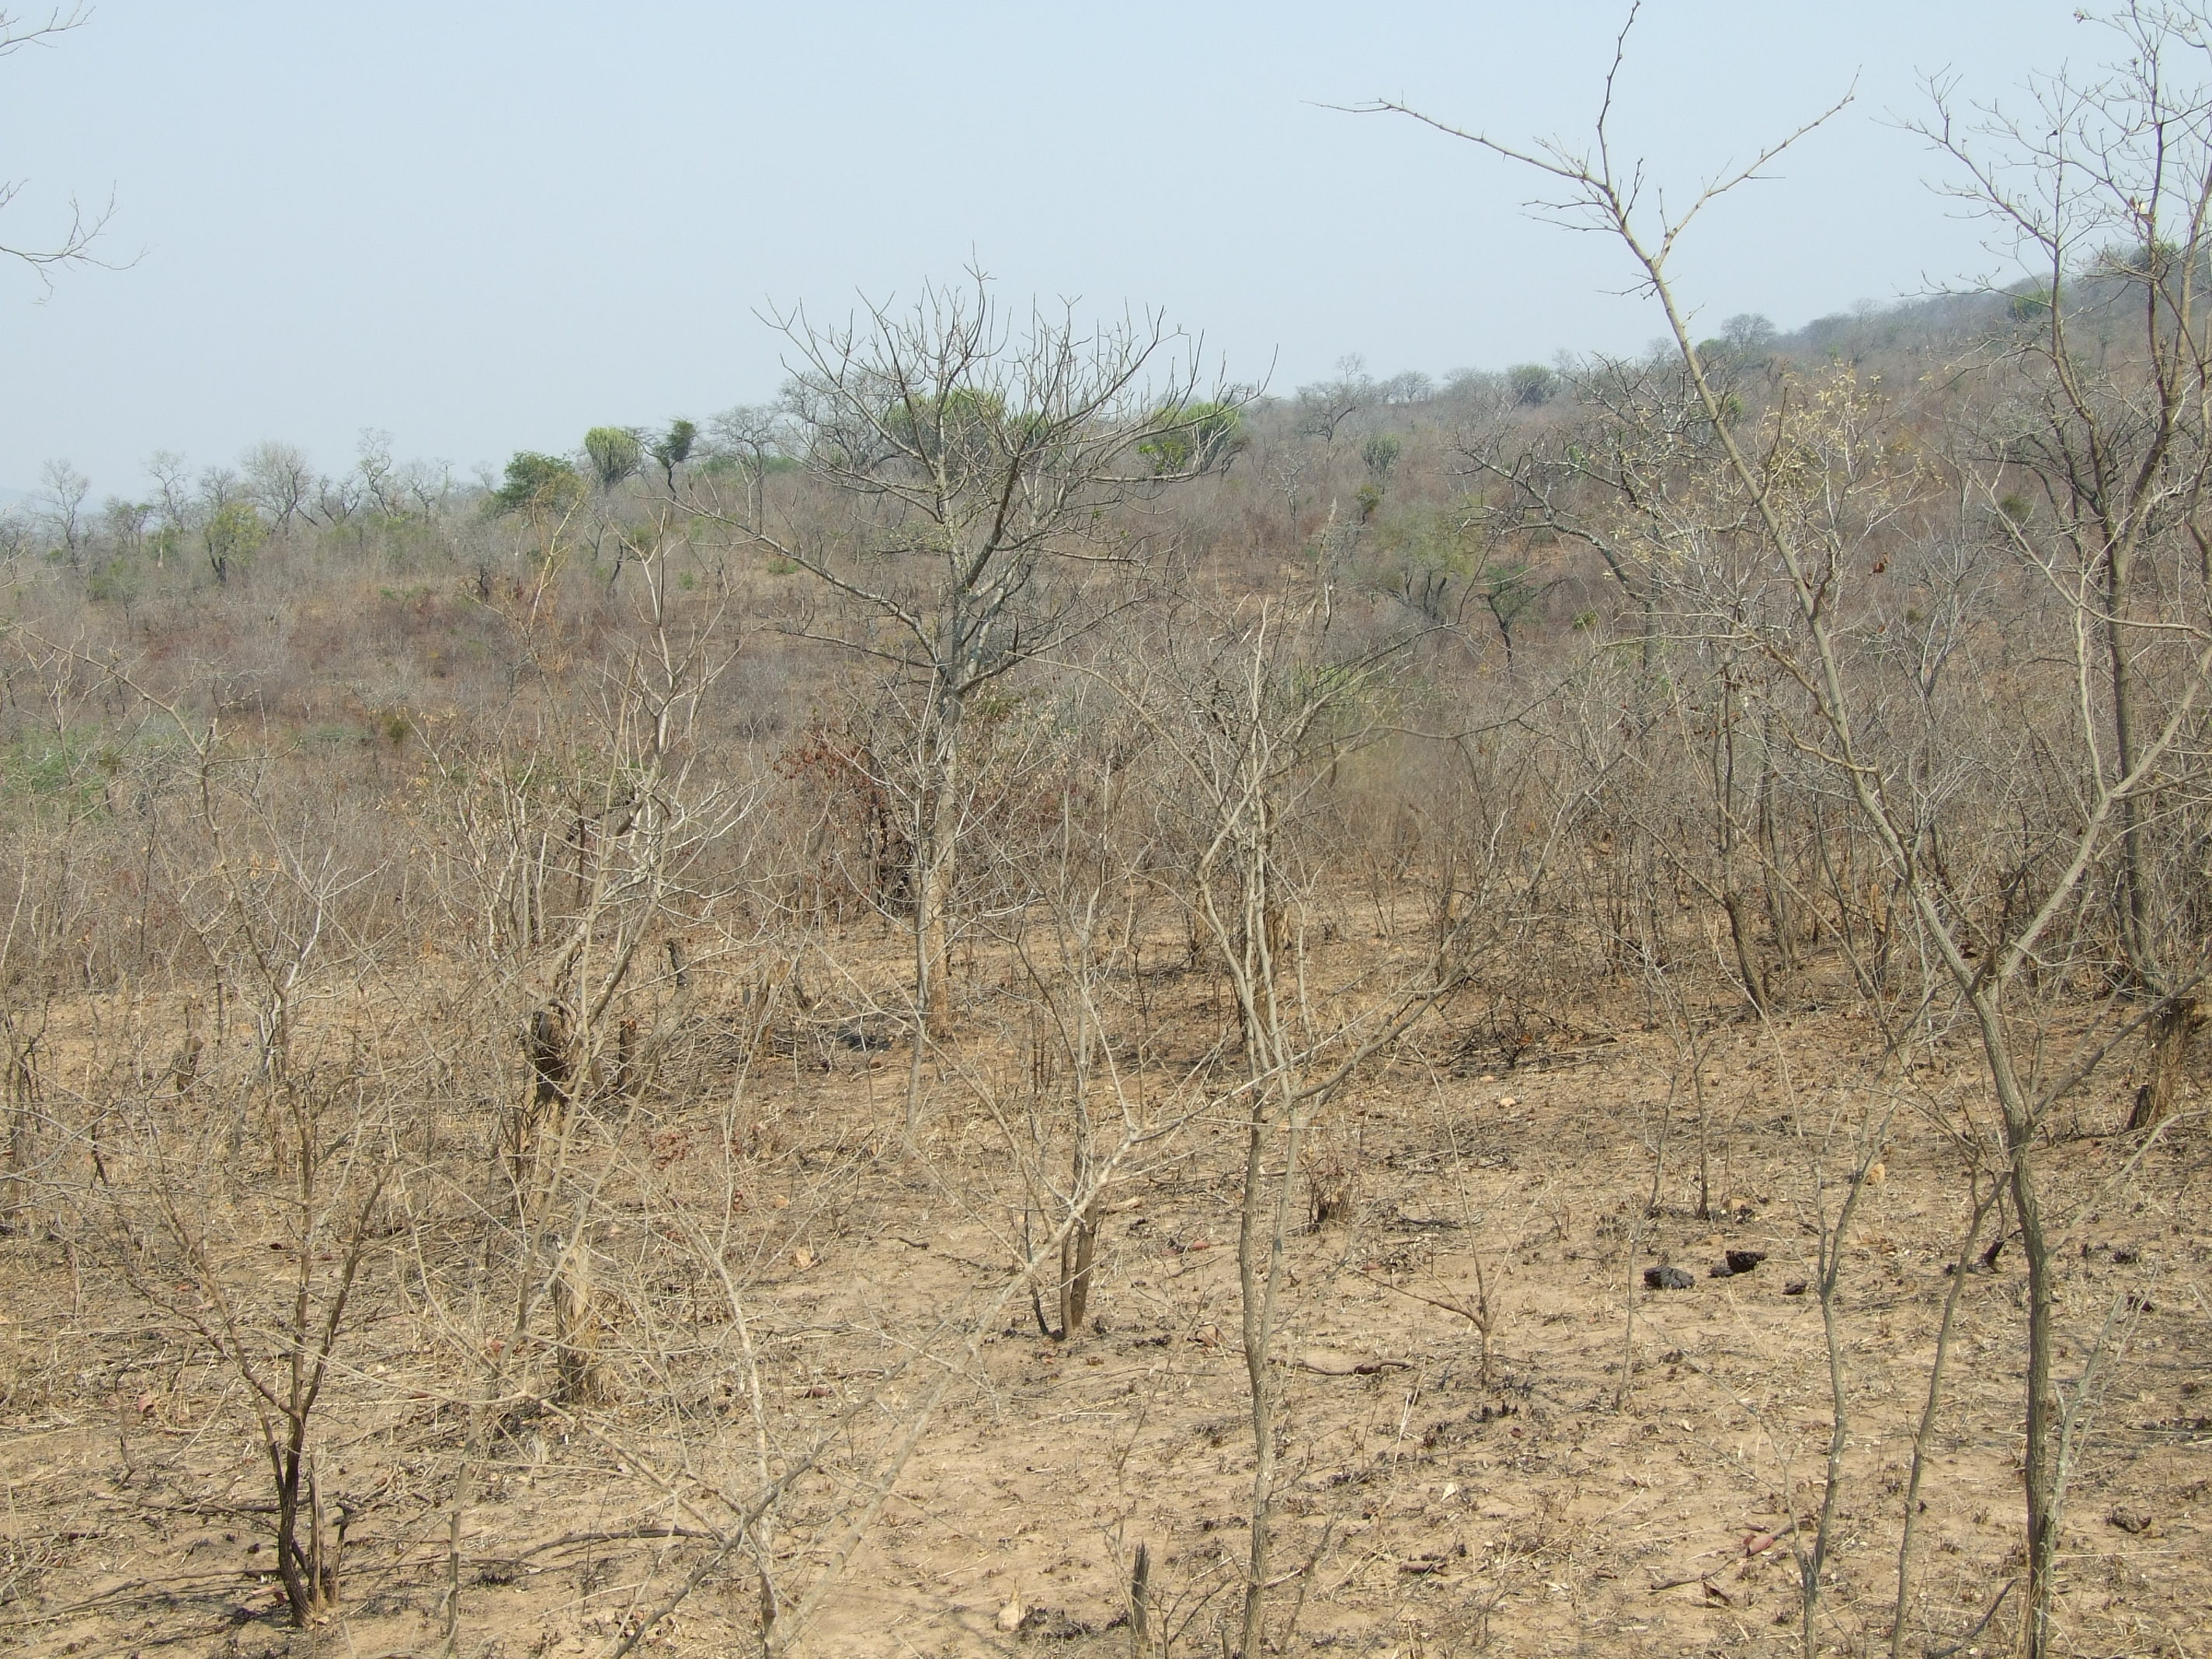

Figure 1: Degraded woodland in the sytudy area, which is the dominant vegetation type. Note how the grass cover has been depleted by heavy grazing.

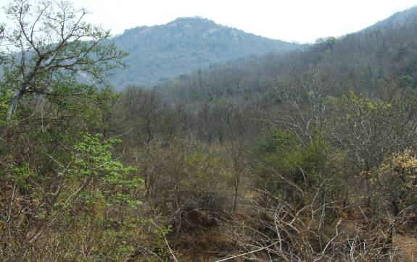

Figure 2: Woodland against the mountain slopes in the study area has been less impacted by grazing and agriculture.

    - Afromontane forest
This vegetation type occurs at sea level in the south of the country, but at progressively higher altitude towards the east and north of the country. Small pockets of this vegetation type are evident in south facing valleys in 3330AA, in some of the remote mountain areas. The alignment does not cross any of the valleys; therefore no impacts are expected in these areas.

  - Bird micro-habitats

Whilst much of the bird species distribution in the study area can be explained in terms of the above broad vegetation description (based on the quarter degree squares), there are many differences in bird species distribution and density that correspond to differences in habitat at the micro level. These “bird micro-habitats” are evident at a much smaller spatial scale than the broader vegetation types or biomes, and can largely only be identified through a combination of field investigation and experience. It is therefore extremely important to visit the study area first hand.

The following bird micro-habitats were identified during the field investigation.

    - Arable lands
Arable or cultivated land represents a significant feeding area for many bird species in any landscape for the following reasons: through opening up the soil surface, land preparation makes many insects, seeds, bulbs and other food sources suddenly accessible to birds and other predators; the crop or pasture plants cultivated are often eaten themselves by birds, or attract insects which are in turn eaten by birds; during the dry season arable lands often represent the only green or attractive food sources in an otherwise dry landscape. The study area contains extensive areas of cultivated land, mostly maize, as well as fallow lands which are heavily grazed by livestock. These open areas are sometimes favoured by raptors as it makes prey more accessible, and species such as Secretarybird Sagittarius serpentarius, White Stork Ciconia ciconia and Abdim’s Stork Ciconia abdimii may from time to time forage here.
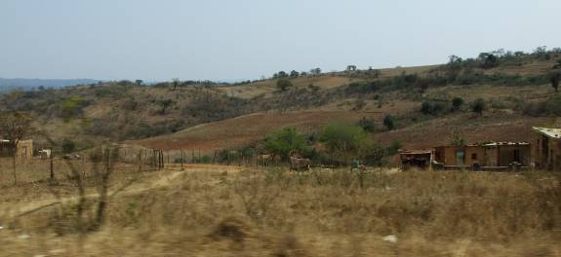

Figure 3: Example of arable lands in the study area.

    - Rivers or drainage lines
Most rivers in southern Africa are in the east and extreme south, in the higher rainfall areas. Thirteen species of water bird are mostly restricted to riverine habitat in southern Africa. The map distribution of these species correlates with the river courses in southern Africa. The prominent river that occurs within the immediate study area, is the Klein Letaba River River. Several Red Data species listed in TABLE 1 could potentially occur along the river, these include all the storks, African Finfoot Podica senegalensis and Half-collared Kingfisher Alcedo semitorquata. It must be noted that the banks of the river has some infestation with alien vegetation, and perhaps more importantly, has had most of the riparian vegetation removed with agriculture often right up to the river margin. Rivers are extremely important sources of water for most bird species and will be regularly utilised not only as a source of drinking water and food, but also for bathing. It is clear that the Klein Letaba River in the study area has been heavily impacted by human activity, thus making it less desirable to birds that would, under more favourable conditions, utilise this river more extensively. Notwithstanding, it remains important for birds.
FIGURE 3: Drainage line

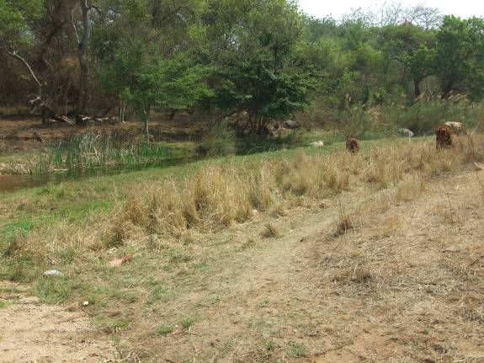
Figure 4: The Klein Letaba River in the study area.

    - Dams
Many thousands of earthen and other dams exist in the southern African landscape. Whilst dams have altered flow patterns of streams and rivers, and affected many bird species detrimentally, a number of species have benefited from their construction. The construction of these dams has probably resulted in a range expansion for many water bird species that were formerly restricted to areas of higher rainfall. Man made impoundments, although artificial in nature, can be very important for variety of birds, particularly waterbirds. Apart from the water quality, the structure of the dam, and specifically the margins and the associated shoreline and vegetation, plays a big role in determining the species that will be attracted to the dam. In this instance, there are dams in the study area, although due to access problems, no close-up view of the dams could be obtained. However, from satellite imagery, the location of dams was established that could potentially serve as draw cards for waterbirds. Several Red Data species listed in TABLE 1 could potentially occur at these dams, particularly the storks and ducks, including Red Data species such as African Pygmy Goose Netapus aurittus. The dams are situated at the following coordinates:

Dam No 1: 23 25 37S 29 56 50E
Dam No 2: 23 24 46S 29 59 08E
Dam No 3: 23 13 05S 30 11 13E
Dam No 4: 23 09 20S 30 13 09E

  - Bird species present in the study area

TABLE 2 below lists of the Red Data bird species reported in the study area during the Southern African Bird Atlas Project (Harrison et al 1997), as well as their favourite habitat and the chances of them occurring close to the alignment.

TABLE 2. Red Data species recorded in each quarter degree square in the study area

Species | Red Data status (Barnes 2000) | Habitat requirements (Barnes 1998; Barnes 2000; Hockey et.al.2005; Young et.al.2003; Harrison et.al.1997; Chittenden 2007; personal observations) | Likelihood of occurrence along the alignment
Cape Parrot Poicephalus robustus | EN | Mostly found in Afro-montane forest | Low, no suitable habitat
African Crowned Eagle Stephanoaetus coronatus | NT | Afro-montane forest and dense riverine woodland | Low, no suitable habitat
African Finfoot  Podica senegalensis | VU | Sheltered rivers and streams within woodland areas | High, could be encountered along the Klein Letaba River .
African Marsh-Harrier Circus ranivorus | VU | Inland and coastal wetlands and adjacent moist grassland | Low, no major wetlands along the proposed alignment.
African Openbill Anastomus lamelligerus | NT | Wetlands, floodplains, shallow rivers, dams and lagoons. | Medium, could be a visitor to the dams in the study area.
African Pygmy-Goose Nettapus auritus | NT | Large vegetated waterbodies, particularly with water lilies. | Medium, could be a visitor to the dams in the study area.

Bat Hawk Macheiramphus alcinus | NT | Mostly woodland, favouring habitats with nearby riverine woodland and associated large populations of bats and their roosting sites. | Medium, could be encountered close to the Klein Letaba River. Might be roosting in large Eucalyptus trees.
Bateleur Terathopius ecaudatus | VU | Savanna woodland and bushveld | Low, generally very rare outside protected areas.
Black Stork  Ciconia nigra | NT | Rivers, large dams, often associated with cliffs. | Medium, could be a visitor to the dams in the study area.
Black-bellied Bustard Lissotis melanogaster | NT | Dense grassland and wooded savanna | Low, grass cover is generally kept short due to heavy grazing.
Cape Vulture  Gyps coprotheres | VU | Large cliffs for breeding and roosting, open woodland and grassland. Roosts on transmission lines. | Medium, may be a visitor to the area. Closest breeding colony is in the Soutpansberg.
Half-collared Kingfisher Alcedo semitorquata | NT | Fast-flowing streams with clear water and well-wooded banks | High, could be encountered along the Klein Letaba River .
Lanner Falcon  Falco biarmicus | NT | Generally prefers open habitat, but exploits a wide range of habitats. | High, could be encountered in any habitat. Often use abandoned crow nests in pylons for breeding.
Lesser Flamingo Phoenicopterus minor | NT | Open shallow, euthropic wetlands. Can tolerate more saline and alkaline conditions than the Greater Flamingo. Could be present at some of the larger waterbodies and farm dams in the study area. | Low, could be a sporadic visitor to dams in the area, depending on water levels.
Martial Eagle Polemaetus bellicosus | VU | Open grassland and arid woodland | High, could be encountered anywhere in the study area, but particularly in open woodland..
Pallid Harrier  Circus macrourus | NT | Grassland associated with open plains or floodplains | Low, no suitable habitat next to the proposed alignments.
Pink-backed Pelican Pelecanus rufescens | VU | Wetlands, dams and estuaries | Low, could be a sporadic visitor to dams in the area, depending on water levels.
Red-billed Oxpecker Buphagus erythrorhynchus | NT | Savanna woodland and bushveld with large ungulates. | High, due to large numbers of cattle. No impacts expected from power lines. No impacts expected from power line
Secretarybird Sagittarius serpentarius | NT | Grassland, old lands, open woodland. | High, especially in abandoned lands and open woodland.
Short-clawed Lark Certhilauda chuana | NT | Sparsely vegetated, semi-arid, overgrazed Acacia woodland | Unsure, but habitat seems to be suitable.
White-backed Vulture Gyps africanus | VU | Savanna woodland and bushveld | High, could be attracted by livestock.
Yellow-billed Stork Mycteria ibis | NT | Shorelines of large waterbodies. | Low, could be a sporadic visitor to dams in the area, depending on water levels.

PREDICTIVE METHODS

The following methods were employed in predicting the impacts of the proposed power line on birds:

- A 1:50 000 map of the study area was obtained showing existing infrastructure and the proposed alignment. This was used as far as possible in order to identify potential “hot-spots” along the corridors e.g. patches of undisturbed vegetation, river crossings, wetlands, dams, and agricultural areas.
- High resolution Google Earth imagery was used to identify vegetation patterns and potential “hot-spots” along the corridors e.g. patches of undisturbed vegetation, river crossings, wetlands, dams, and agricultural areas.
- The Atlas of southern African Birds (ASAB) (Harrison et.al, 1997) species lists and vegetation classifications of each of the quarter degree squares (or 1: 50 000 map units), within which the alignment is located were obtained from the Avian Demography Unit at the University of Cape Town. These were used to determine which power line sensitive species were recorded in the area during the Atlas period, and which species could potentially occur there in future.
- The area was visited to obtain a first-hand perspective of the proposed routes and birdlife. An attempt was made to travel and view the alignment as far as was practically possible, and photographs were taken of representative habitat.
- The impacts were predicted on the basis of experience in gathering and analysing data on wildlife impacts with power lines throughout southern Africa since 1996 (see van Rooyen & Ledger 1999 for an overview of methodology), supplemented with local knowledge and first hand observations.
- It is important to note that, although the predicted impacts are mostly concerned with Red Data species, the non Red Data species will benefit as much from the proposed mitigation measures as they share the same habitat and face the same impacts as the Red Data species.

EVALUATION OF IMPACTS

Because of their size and prominence, electrical infrastructures constitute an important interface between wildlife and man. Negative interactions between wildlife and electricity structures take many forms, but two common problems in southern Africa are electrocution of birds (and other animals) and birds colliding with powerlines. (Ledger & Annegarn 1981; Ledger 1983; Ledger 1984; Hobbs & Ledger 1986a; Hobbs & Ledger 1986b; Ledger et.al.. 1992; Verdoorn 1996; Kruger & Van Rooyen 1998; Van Rooyen 1998; Kruger 1999; Van Rooyen 1999; Van Rooyen 2000). Other problems are electrical faults caused by bird excreta when roosting or breeding on electricity infrastructure, (Van Rooyen & Taylor 1999) and disturbance and habitat destruction during construction and maintenance activities.

4.1. Electrocutions
Electrocutions of birds on overhead lines are an emotional issue as well as an important cause of unnatural mortality of raptors and storks. It has attracted plenty of attention in Europe, USA and South Africa (APLIC 1994; Alonso & Alonso 1999; van Rooyen & Ledger 1999). However, in the context of overhead lines above 132 kV, electrocutions are not a major issue. Electrocution refers to the scenario where a bird is perched or attempts to perch on the electrical structure and causes an electrical short circuit by physically bridging the air gap between live components and/or live and earthed components (van Rooyen 2004). Due to the large size of the clearances on most overhead lines of above 132kV, electrocutions are generally ruled out as even the largest birds cannot physically bridge the gap between dangerous components. In fact, transmission lines have proven to be beneficial to many birds, including species such as Martial Eagles, Tawny Eagles, White-backed Vultures, and even occasionally Verreaux’s Eagles Aquila verreauxii by providing safe nesting and roosting sites in areas where suitable natural alternatives are scarce (van Rooyen 2004). Cape Vultures have also taken to roosting on power lines in ertain areas in large numbers (van Rooyen 2004b), while Lappet-faced Vultures Torgos tracheliotis are also known to using power lines as roosts, especially in areas where large trees are scarce (pers.obs.).

4.2 Collisions
Collisions are the biggest single threat posed by transmission lines to birds in southern Africa (van Rooyen 2004). Most heavily impacted upon are bustards, storks, cranes and various species of waterbirds. These species are mostly heavy-bodied birds with limited maneuverability, which makes it difficult for them to take the necessary evasive action to avoid colliding with power lines (van Rooyen 2004, Anderson 2001).

Unfortunately, many of the collision sensitive species are considered threatened in southern Africa. In the period August 1996 to March 2003, seventy-four percent of collision mortalities on Eskom transmission lines that were recorded on the EWT’s central incident register of power line mortalities were South African Red Data species (van Rooyen 2003)(see table 3 below).

TABLE 3: Red Data species (Barnes 2000) collision mortalities on Eskom transmission lines between August 1996 and March 2003, recorded on the EWT central incident register (van Rooyen 2003):

Species | Number
Ludwig’s Bustard Neotis ludwigii | 77
Blue Crane Anthropoides paradisea | 47
White Stork Ciconia ciconia  (not included in the SA Red Data book, but protected under the Bonn Convention on Migratory Species) | 25
Greater Flamingo Phoenicopterus ruber | 22
Kori Bustard Ardeotis kori | 9
Cape Griffon Gyps coprotheres | 9
Grey Crowned Crane Balearica regulorum | 8
Stanley’s Bustard Neotis denhami | 4
Secretarybird Sagittarius serpentarius | 3
Lesser Flamingo Phoenicopterus minor | 3
African Whitebacked Vulture Gyps africanus | 2
Tawny Eagle Aquila rapax | 1
Martial Eagle Polemaetus bellicosus | 1
Lappetfaced Vulture Torgos tracheliotus | 1
Corncrake Crex crex | 1

Although significant in itself, the figures are not a true reflection of the extent of the problem, because none of the collision localities were closely monitored over a substantial period of time. Where long term monitoring did happen, the picture is disturbing. In one instance, where bi-monthly monitoring did take place, a single 10 km section of 132kV distribution line killed 59 Blue Cranes, 29 Ludwig’s Bustard, and 13 White Storks in a three year period (EWT unpubl. data). In 2004, fifty-four Blue Crane carcasses were discovered near Graaf-Reinett in the Northern Cape province under 3.7km of distribution line (EWT unpubl. data).

Data collected in the Northern Cape province between 1997 and 1999 provides further evidence of the gravity of the problem. During an initial clearing of transects, a total of 194 large bird carcasses were found under 40km of Transmission line (220 and 400kV) near De Aar in the Northern Cape. Subsequent monitoring of 140 km of powerlines (transects of 10km each from 22kV up to 400kV) in the same area over a period of 12 months produced another 196 carcasses (mostly cranes and bustards), the majority under transmission lines (Anderson 2001).
The Red Data species vulnerable to powerline collisions are generally long living, slow reproducing species under natural conditions. Some require very specific conditions for breeding, resulting in very few successful breeding attempts, or breeding might be restricted to very small areas. A good example of this is the two flamingo species that occur in southern Africa, which have experienced hardly any successful breeding attempts at Etosha Pan in Namibia for several decades (Williams & Velasquez 1997). Another example is the Great White Pelican that only breeds successfully at Dassen Island in the Western Cape. These species have not evolved to cope with high adult mortality, with the results that consistent high adult mortality over an extensive period could have a serious effect on a population’s ability to sustain itself in the long or even medium term. Many of the anthropogenic threats to these species are non-discriminatory as far as age is concerned (e.g. habitat destruction, disturbance and power lines) and therefore contribute to adult mortality, and it is not known what the cumulative effect of these impacts could be over the long term.
From the figures quoted above, it is clear that power lines are a major contributory cause of avian mortality among power line sensitive species, especially Red Data species. Furthermore, the cumulative effects of power lines and other sources of unnatural mortality might only manifest itself decades later, when it might be too late to reverse the trend. It is therefore imperative to reduce any form of unnatural mortality in these species, regardless of how insignificant it might seem at the present moment in time.

4.3 Habitat destruction
During the construction phase and maintenance of power lines, some habitat destruction and alteration inevitably takes place. This happens with the construction of access roads, and the clearing of servitudes. Servitudes have to be cleared of excess vegetation at regular intervals in order to allow access to the line for maintenance, to prevent vegetation from intruding into the legally prescribed clearance gap between the ground and the conductors and to minimize the risk of fire under the line which can result in electrical flashovers. These activities have an impact on birds breeding, foraging and roosting in or in close proximity of the servitude, both through modification of habitat and disturbance caused by human activity.

4.4 Evaluation of expected impacts on sensitive species in study area
Generally speaking, it is unavoidable that birds get killed through interaction with infrastructure, including power lines, despite the best possible mitigation measures. It is therefore important to direct risk or impact assessments and mitigation efforts towards species that have a high biological significance, in order to achieve maximum results with the available resources at hand. A pure scientific approach would only consider the effects of deaths on the sustainability of the population, but society places other values on certain species, e.g. aesthetic or commercial, which cannot be accounted for in a pure scientific approach.

In accordance with this principle, this impact assessment is primarily aimed at assessing the potential threat to threatened or Red Data species (biological significance) that occur or potentially along the proposed power line routes (see APPENDIX A). However, as mentioned earlier, the proposed mitigation measures will benefit all the birds occurring in the study area, not just the Red Data species.

Each predicted impact on the Red Data bird species of the study area, was evaluated against a set of criteria shown in APPENDIX B. The impacts which scored a MEDIUM for “Magnitude and significance” are discussed further below.

    - Collision with earth wire
Species most likely to be impacted on through collision with the earth wire and the likely locality of this impact are as follows:
- Black Stork, African Openbill, Yellow-billed Stork, African Pygmy-Goose, Pink-backed Pelican and Lesser Flamingo at dams.
- Cape Vulture and White-backed Vulture mostly at dams when visiting to drink or bath.
- Black Stork, African Openbill and Yellow-billed Stork in rivers, particularly the Klein Letaba River.
- White Stork and Secretarybird at arable lands.
- Various non Red Data species of waterbirds close to water sources such as rivers and dams.

    - Electrocution on pylons
The single steel pole design is generally a safe design from an electrocution perspective. The only recorded species that have been electrocuted on these designs are Cape Vultures (EWT unpubl. data). The insulator length of 1.5 metres is smaller than the wingspan of a vulture, which means that if a vulture decides to attempt to land on an insulator, there is a real risk of a phase-earth electrocution as it can conceivably bridge the gap between the phase conductor and the steel, earthed pole. Species most likely to be potentially impacted are Cape Vultures and White-backed Vultures, if they are congregating at water or at a carcass.

    - Habitat destruction
The species considered likely to be impacted on at a MEDIUM level by this line is the Half-collared Kingfisher and African Finfoot. This impact could occur in riverine vegetation if it needs to be cleared to make way for the line. The general lack of significant impacts by habitat destruction is largely due to the already relatively highly degraded nature of most of the study area. However, the further removal of any of the remaining large trees could impact on raptors in general, as it deprives them of roosting and nesting substrate.

Both the proposed alternative sites for the Singo substation can be described as degraded woodland (see figures 5) with no large trees. It is unlikely that the larger Red Data species mentioned in this report will be significantly adversely affected by the construction of the substation and the resultant loss of 1 hectare of degraded woodland. This type of habitat is fairly well represented in the area and due to the mobility of the larger species, they could conceivably move out of the immediate area and forage elsewhere in similar habitat. The species that are most likely to be affected by the loss of habitat are the smaller species that are currently resident in that hectare of vegetation. It is not envisaged that any Red Data species will be permanently displaced by the habitat transformation that will take place as a result of the construction of the Singo substation.

Figure 5: Degraded woodland at the sites of the proposed Singo substation.

The proposed alternative site 1 for the Mashau substation can be described as degraded woodland (see figures 6 and 7), while alternative site 2 is situated in an agricultural field. As with Singo, it is unlikely that the larger species mentioned in this paragraph will be significantly adversely affected by the construction of the substation and the resultant loss of 1 hectare of either degraded woodland or a part of an agricultural field. Both these types of habitat are fairly well represented in the area and due to the mobility of the larger species, they could conceivably move out of the immediate area and forage elsewhere in similar habitat. The species that are most likely to be affected by the loss of habitat are the smaller species that are currently resident in that hectare of vegetation. It is not envisaged that any Red Data species will be permanently displaced by the habitat transformation that will take place as a result of the construction of the Mashau substation, at either of the two alternative sites.
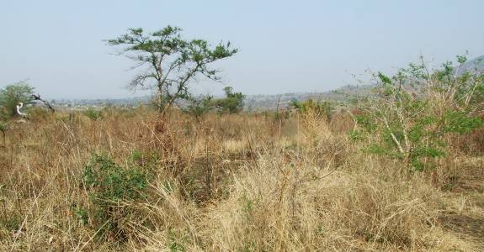

Figure 6: Degraded woodland at Mashau site alternative 1
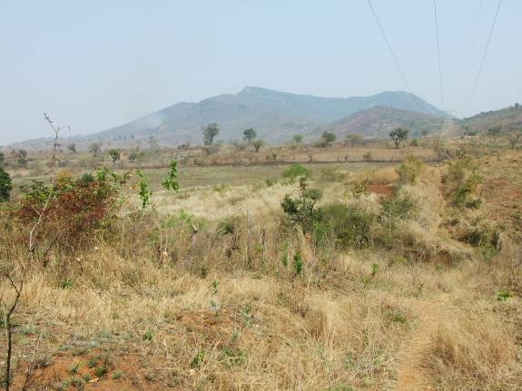
Figure 7: An agricultural field at Mashau site alternative 2.

RECOMMENDATIONS

The following recommendations are made in order to best mitigate for the specific impacts described above:

  - Collision with earth wire
Bird Flight Diverters should be fitted on the earth wire as indicated on the risk maps APPENDIX C.

  - Electrocution on pylons
In order to prevent the electrocution of any birds on the pylons, all pylons should be fitted with a standard type, Eskom approved “bird perch” at the top of the pole. This will provide ample safe perching space for any birds well clear of the dangerous hardware.

  - Habitat destruction
All construction, maintenance and decommissioning activities must be carried out according to best environmental practice principles so as to minimize habitat destruction. In particular, care is to be taken not to impact on riverine vegetation in any way, and the removal of large trees must not happen.

REFERENCES

Alonso, J. A., Alonso, J. C., 1999. Mitigation of bird collisions with transmission lines through groundwire marking. In: Ferrer M and Janss F E (eds), Birds and powerlines, pp113 - 124, Quercus, Madrid, Spain.

Avian Power Line Interaction Committee (APLIC). 1994. Mitigating Bird Collisions with Power Lines: The State of the Art in 1994. Edison Electric Institute. Washington D.C.

Anderson, M.D., 2001. The effectiveness of two different marking devices to reduce large terrestrial bird collisions with overhead electricity cables in the eastern Karoo, South Africa. Draft report to Eskom Resources and Strategy Division. Johannesburg. South Africa.

BARNES, K.N. (ed.) 2000. The Eskom Red Data Book of Birds of South Africa, Lesotho and Swaziland. BirdLife South Africa, Johannesburg.

HARRISON, J.A., ALLAN, D.G., UNDERHILL, L.G., HERREMANS, M., TREE, A.J., PARKER, V & BROWN, C.J. (eds). 1997. The atlas of southern African birds. Vol. 1&2. BirdLife South Africa, Johannesburg.

HOBBS, J.C.A. & LEDGER J.A. 1986a. The Environmental Impact of Linear Developments; Power lines and Avifauna. Third International Conference on Environmental Quality and Ecosystem Stability. Israel, June 1986.

HOBBS, J.C.A. & LEDGER J.A. 1986b. Power lines, Birdlife and the Golden Mean. Fauna and Flora 44:23-27.

KRUGER, R. & VAN ROOYEN, C.S. 1998. Evaluating the risk that existing power lines pose to large raptors by using risk assessment methodology: the Molopo Case Study. 5th World Conference on Birds of Prey and Owls: 4 - 8 August 1998. Midrand, South Africa.

KRUGER, R. 1999. Towards solving raptor electrocutions on Eskom Distribution Structures in South Africa. M. Phil. Mini-thesis. University of the Orange Free State. Bloemfontein. South Africa.

LEDGER, J. 1983. Guidelines for Dealing with Bird Problems of Transmission Lines and Towers. Escom Test and Research Division Technical Note TRR/N83/005.

LEDGER, J.A. & ANNEGARN H.J. 1981. Electrocution Hazards to the Cape Vulture (Gyps coprotheres) in South Africa. Biological Conservation 20:15-24.

LEDGER, J.A. 1984. Engineering Solutions to the problem of Vulture Electrocutions on Electricity Towers. The Certificated Engineer. 57:92-95.

LEDGER, J.A., J.C.A. HOBBS & SMITH T.V. 1992. Avian Interactions with Utility Structures: Southern African Experiences. Proceedings of the International Workshop on Avian Interactions with Utility Structures, Miami, Florida, 13-15 September 1992. Electric Power Research Institute.
LOW, A.B. & ROBELO, A.G. (eds). 1996. Vegetation of South Africa, Lesotho and Swaziland. Department of Environmental Affairs and Tourism, Pretoria.
McCann, K., Morrison, K., Byers, A., Miller, P. & Friedman, Y. (eds). 2001. Population and Habitat Viability Assessment for the Blue Crane (Anthropoides paradiseus). Conservation Breeding Specialist Group (SA), Endangered Wildlife Trust, Johannesburg.

VAN ROOYEN, C.S. & LEDGER, J.A. 1999. Birds and utility structures: Developments in southern Africa. Pp 205-230 in Ferrer, M. & G..F.M. Janns. (eds.) Birds and Power lines. Quercus, Madrid, Spain. 238pp.

VAN ROOYEN, C.S. 1998. Raptor mortality on power lines in South Africa. 5th World Conference on Birds of Prey and Owls: 4 - 8 August 1998. Midrand, South Africa.

VAN ROOYEN, C.S. 1999. An overview of the Eskom - EWT Strategic Partnership in South Africa. EPRI Workshop on Avian Interactions with Utility Structures 2-3 December 1999, Charleston, South Carolina.

VAN ROOYEN, C.S. 2000. An overview of Vulture Electrocutions in South Africa. Vulture News 43: 5-22. Vulture Study Group, Johannesburg, South Africa.

Van Rooyen, C.S., 2003. Mitigation Programme for Avian Collisions with Eskom Transmission Lines. Unpublished Progress Report, September 2003. Endangered Wildlife Trust, Johannesburg, South Africa.

Van Rooyen, C.S., 2004. The Management of Wildlife Interactions with overhead lines. In: The Fundamentals and practice of Overhead Line Maintenance (132kV and above), pp217-245. Eskom Technology, Services International, Johannesburg 2004.

Van Rooyen, C.S., 2004b. Investigations into vulture electrocutions on the Edwardsdam-Mareetsane 88kV feeder, Unpublished Report, Endangered Wildlife Trust, Johannesburg, South Africa.

VAN ROOYEN, C.S. & TAYLOR, P.V. 1999. Bird Streamers as probable cause of electrocutions in South Africa. EPRI Workshop on Avian Interactions with Utility Structures 2-3 December 1999. Charleston, South Carolina

VERDOORN, G.H. 1996. Mortality of Cape Griffons Gyps coprotheres and African Whitebacked Vultures Pseudogyps africanus on 88kV and 132kV power lines in Western Transvaal, South Africa, and mitigation measures to prevent future problems. 2nd International Conference on Raptors: 2-5 October 1996. Urbino, Italy.

Williams, A. J. Velasquez, C., 1997. Greater Flamingo Phoenicopterus rubber. In: The atlas of southern African birds, Volume 1: Non-passerines, Harrison, J.A., Allan, D.G., Underhill, L.G., Herremans, M., Tree, A.J., Parker, V & Brown, C.J. (eds). Bird Life South Africa, Johannesburg, pp112 - 113.

